HR Attrition & Retention Analysis — Project Report
This report explains the dashboard page-by-page with insights, metrics, methodology, and interpretation. Each dashboard page image is followed by a detailed explanation covering purpose, KPIs, and business value.

Project Overview
This project analyzes workforce attrition and retention trends to help HR leaders understand employee turnover risk, identify vulnerable workforce segments, and strengthen retention programs. The Power BI dashboard provides interactive insights across demographics, tenure, compensation, satisfaction levels, and organizational structure, enabling data‑driven HR decision‑making.

Objectives
• Measure overall attrition and retention performance
• Identify high‑risk departments, roles, and employee groups
• Analyze the impact of income, tenure, overtime, and satisfaction on attrition
• Highlight stability zones with strong retention
• Support HR engagement strategy and workforce planning

Dataset & Tools
Dataset includes employee demographics, job roles, income, tenure, overtime, satisfaction metrics, and attrition status.
Tools & Techniques:
• Power BI • Power Query • Data Modeling • DAX KPI Measures

Methodology
Analysis structured across three stages:
1) Attrition overview & risk identification
2) Compensation & satisfaction influence analysis
3) Retention & workforce stability assessment

Dashboard Page 1 — Attrition Overview & Key Drivers
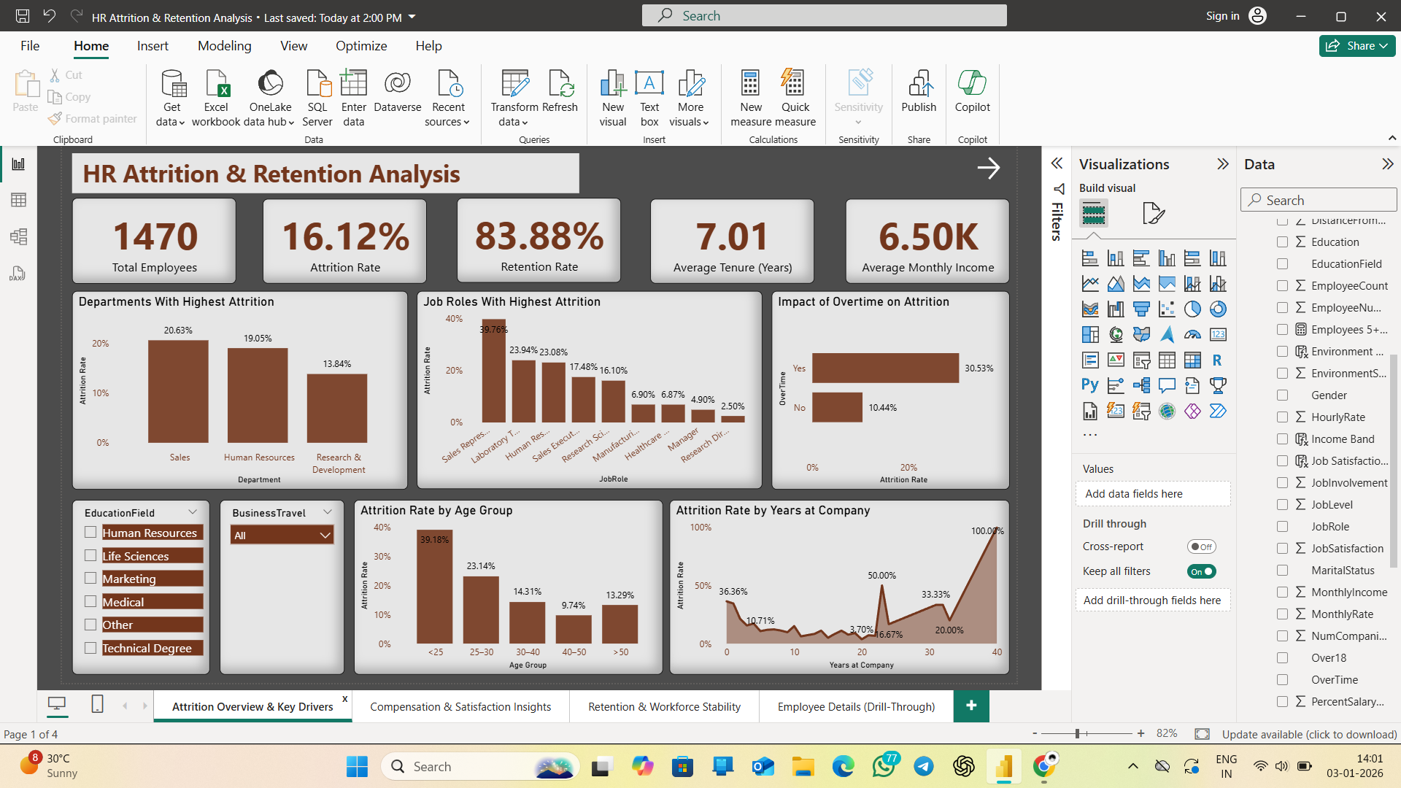
Purpose: Provides a high‑level view of Attrition %, Retention %, Total Employees, Average Tenure, and Average Monthly Income. Identifies where attrition is concentrated across departments, job roles, age groups, and overtime behavior.
Key Visuals & Interpretation:
• Departments & Job Roles With Highest Attrition (%)
• Attrition by Age Group
• Attrition by Years at Company
• Impact of Overtime on Attrition
Key Insights:
• Early‑tenure and overtime employees show higher attrition risk
• Sales and HR job streams are more attrition‑sensitive
• Young‑age segments experience relatively higher turnover

Dashboard Page 2 — Compensation & Satisfaction Insights
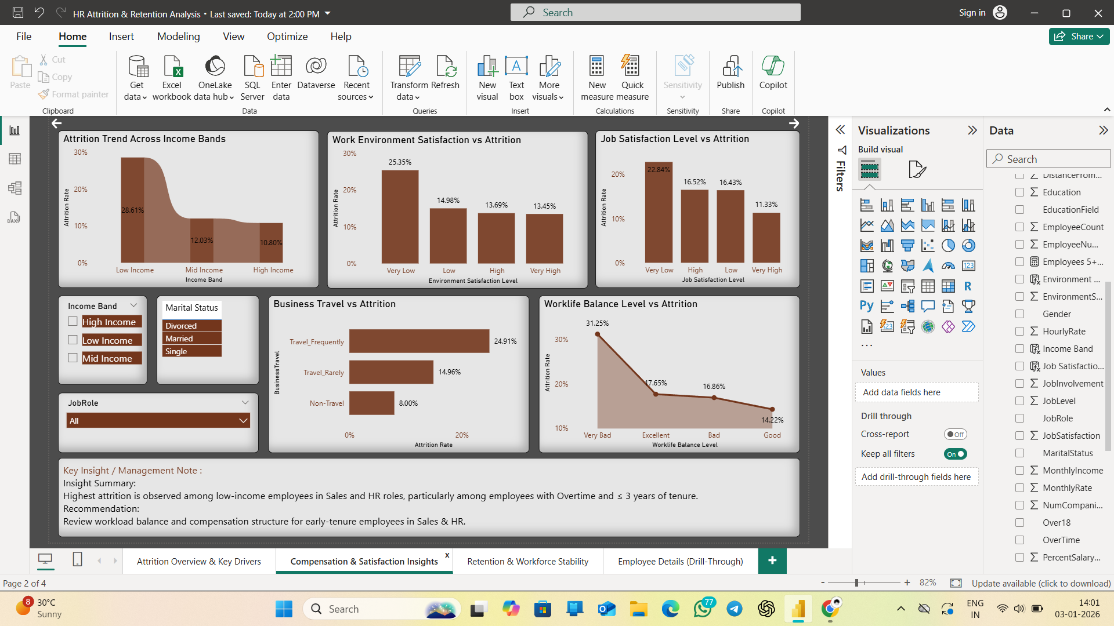
Purpose: Explores how compensation and workplace experience influence attrition outcomes.
Key Visuals & Interpretation:
• Income Band vs Attrition
• Job Satisfaction vs Attrition
• Environment Satisfaction vs Attrition
• Work‑Life Balance vs Attrition
• Business Travel Impact on Attrition
Business Interpretation:
• Low‑income and low‑satisfaction groups display higher attrition
• Poor work‑life balance correlates with turnover behaviour
• Travel‑heavy roles show higher fatigue‑driven exits
Recommendations:
• Compensation review for vulnerable bands
• Engagement & recognition initiatives
• Workload & travel policy balancing

Dashboard Page 3 — Retention & Workforce Stability
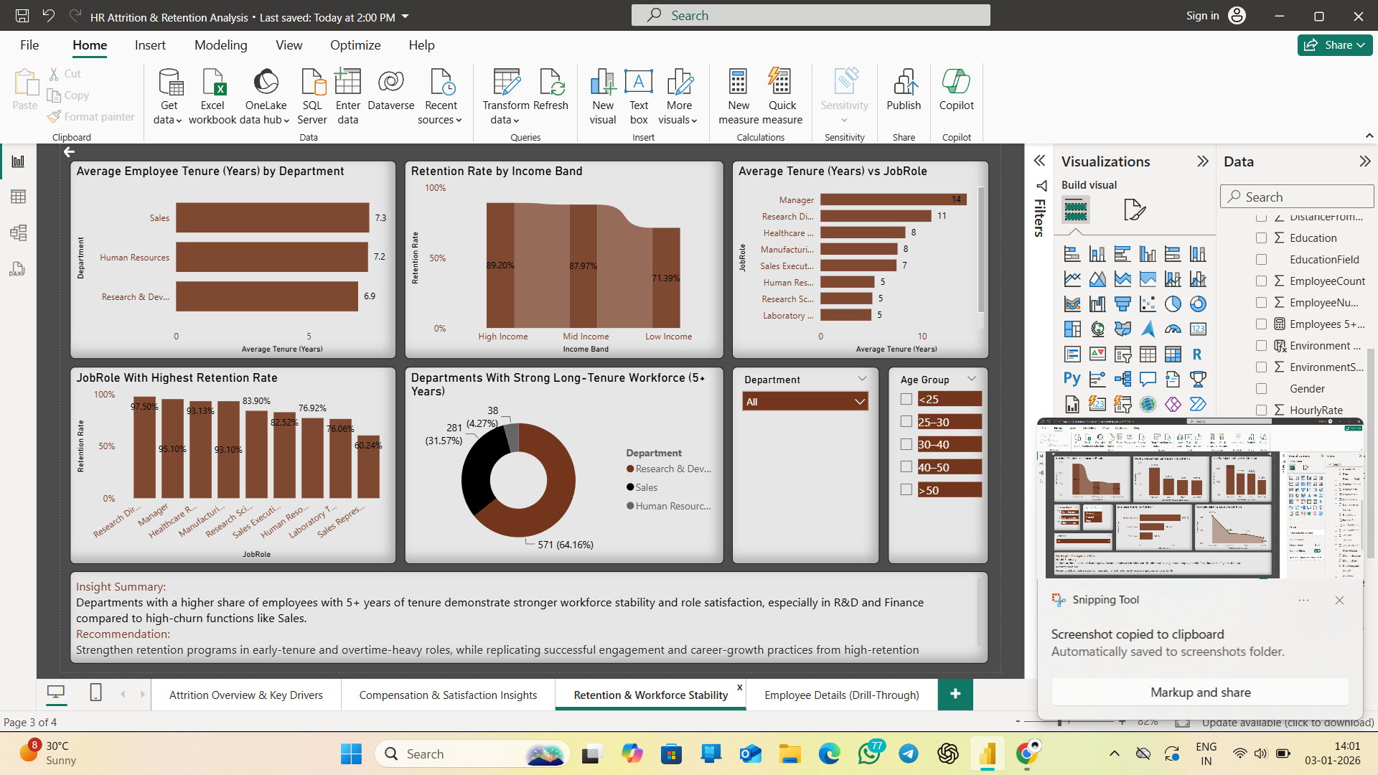
Purpose: Focuses on organizational stability and long‑term employee retention.
Key Visuals & Interpretation:
• Retention % by Department
• Employees with 5+ Years Tenure
• Average Tenure by Function
• Retention vs Income Band
Insights:
• Departments with higher tenure indicate stronger stability
• Mid‑to‑high income groups retain longer
• Long‑serving employees contribute to workforce continuity
Strategic Value:
• Supports succession planning and career‑path initiatives
• Helps benchmark best‑performing retention practices

Drill‑Through Page — Employee Profile & Attrition Details
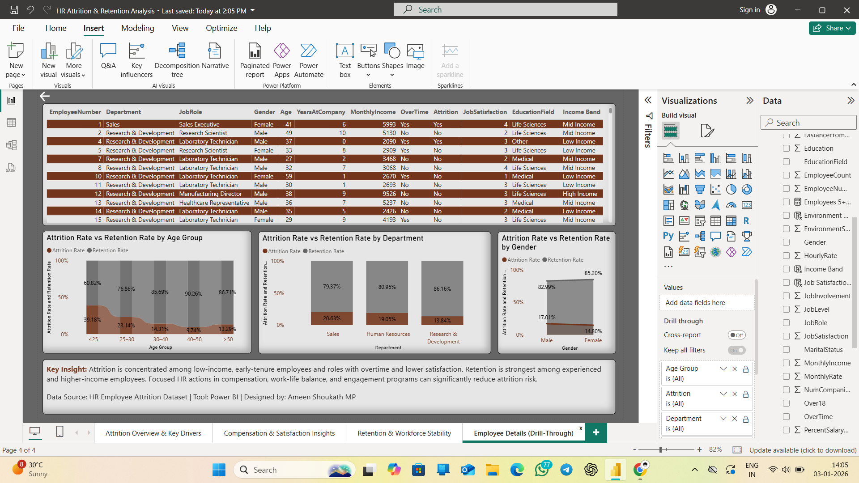
Purpose: Enables deep‑dive investigation at employee‑record level from any visual selection.
Components:
• Employee Details Table (profile, tenure, income, satisfaction, attrition flag)
• Attrition vs Retention comparisons by Department, Age, and Gender
Business Value:
• Supports HR review and exit‑trend investigation
• Enables transparent, case‑level workforce analysis
• Strengthens analytical storytelling for decision‑making

Overall Insights & Recommendations
• Attrition is concentrated among low‑income and early‑tenure employees
• Overtime intensity and weak satisfaction indicators correlate with higher attrition
• Strong retention exists among experienced, higher‑income workforce groups
• Targeted compensation revision, engagement initiatives, and workload balancing can reduce attrition risk

Conclusion
The Attrition & Retention dashboard delivers actionable workforce intelligence, enabling HR leaders to identify risk groups, strengthen retention programs, and support strategic workforce planning.

